Create a instance with 2gb ram and 2 cpu’s take instance type t2.medium

Install docker

After give the permissions

Chmod 700 get-docker.sh

./get-docker.sh

Later install minikube using commands

Later install kubectl using commands

Vi.xxxxx.yml

apiVersion: v1

kind: Pod

metadata:

name: my-pod

labels:

app: my-app

spec:

containers:

- name: my-container

image: nginx:latest

ports:

- containerPort: 80

Kubectl apply –f filename.yml

Kubectl get pods

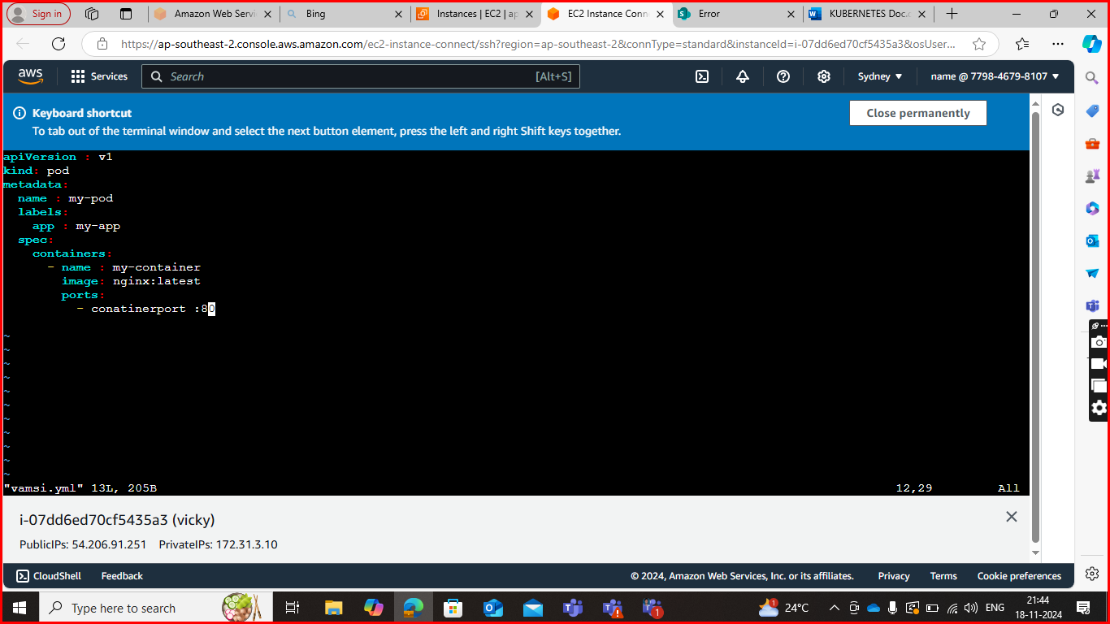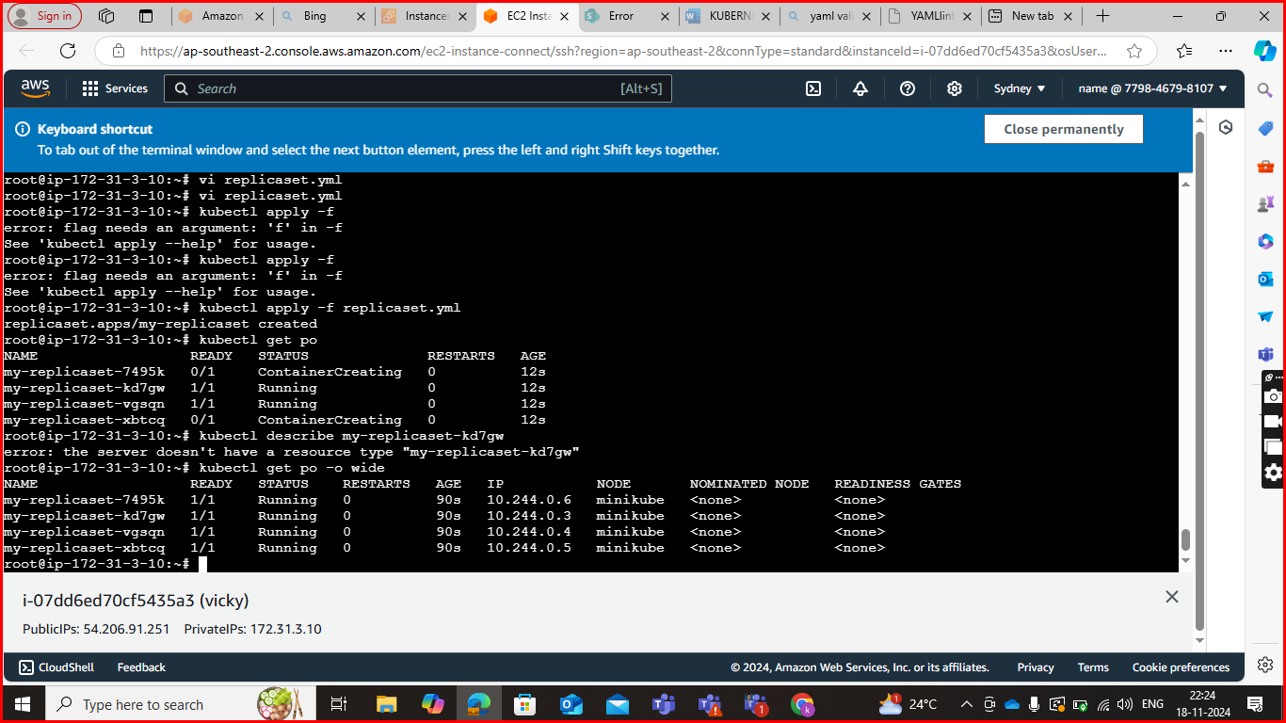

REPLICASET

Mv pod.yml replicaset.yml

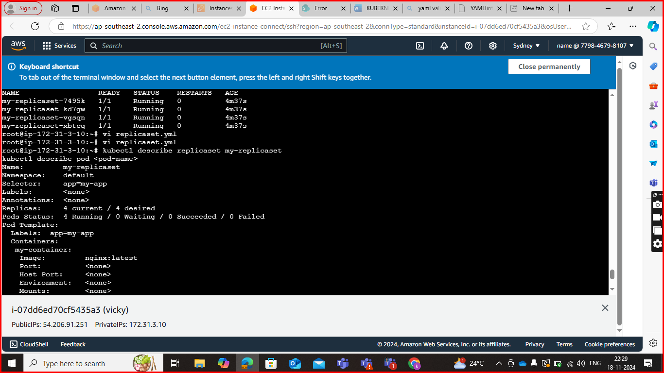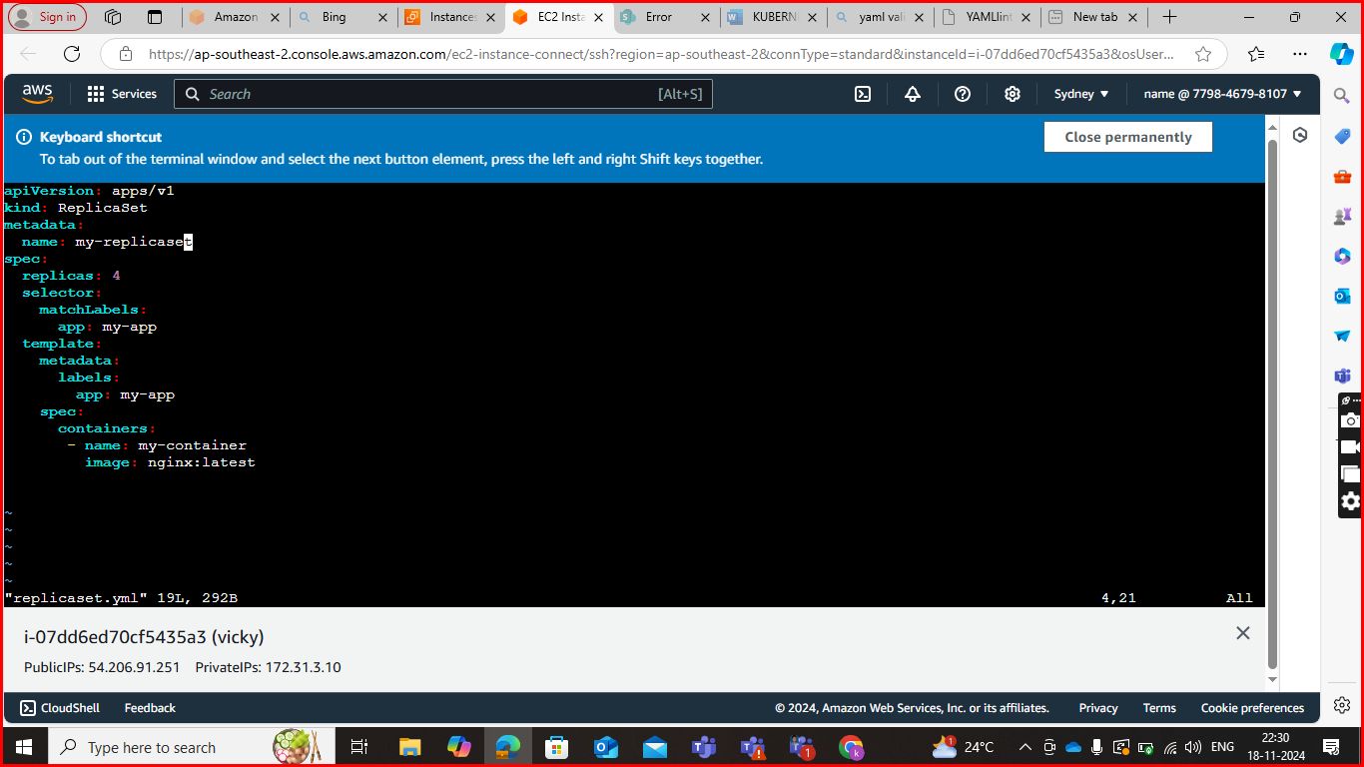

Create a pod command

Kubectl run pod1 –image =nginx

Delete pod

Kubectl delete pod (pod name)

Full information about pod

Kubectl get po –o wide

Particular pod information

Kubectl describe pod (or)podname